Celebrating Bhai Dooj with your Kids

Source: Anisha Nair, Content Developer, First Cry

The bond between siblings is one like no other. In India, the celebration of love between brothers and sisters is a very special one – first with Raksha Bandhan earlier in the year, and then with Bhai Dooj, celebrated on the fourth and final day of the Diwali festivities, i.e. on November 6 this year. This is a good time to tell your kids just why this festival is celebrated, so they can participate with full gusto!
Indian culture and traditions are rich with celebrations of love and bonding in all forms. But what makes “Bhai Dooj” different? It’s association with stories from the past, and the gentle affection that underlies the “Bhai Dooj” rituals!

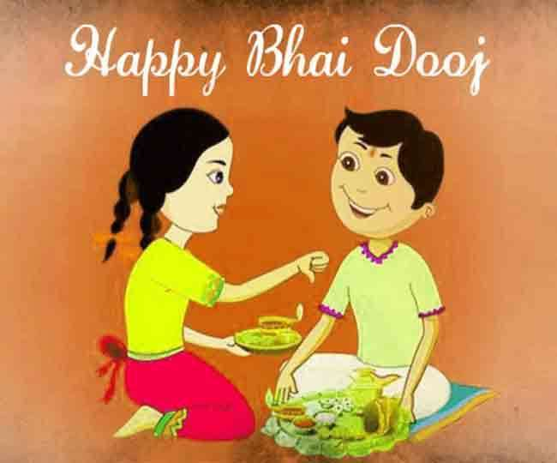

Why We Celebrate Bhai Dooj

The festival can be traced back to celebrating the second day of the new moon – “Bhai’ means brother and “Dooj” means second day post new moon. In the eastern part of India, the festival is known as “Bhai Phonta”. The sisters observe a fast until they apply a sandalwood tilak of goodwill on their brothers’ forehead. In fact, such is the significance of Bhai Dooj that sisters courier/e-mail the “Tika” if their brothers cannot visit them on this day. Talk about keeping a promise!
The Bhaiya Dooj Story

- The story of Lord Yamraj
As per the Ancient Mythology, in the Kartik month of Hindu solar calendar, on the ‘Shukla Paksha Dwitiya’, Lord Yamraj (the god of death) visited his sister Yamuna. She gave a grand welcome to her brother by performing the sacred aarti and applying ‘tilak’ on his forehead. She offered the special delicious dishes that she had prepared for Yamraj. In turn, he showered his blessings on Yamuna. It was on this day that Lord Yamraj gave a boon stating that if on this day, any brother would visit his sister then he would be blessed with utmost health and wealth. Due to this reason, this day is also referred to as ‘’Yam-Dwitiya’’.
- The Story of Lord Krishna
According to another legend, on the second day after the new moon day, Lord Krishna visited his sister Subhadra after killing the Demon King Narkasura. Just as Yamuna had given a grand welcome to Lord Yamraj, in the similar manner, Subhadra also performed the aarti, applied tilak on Lord Krishna’s forehead and sprinkled flowers over him.

How to Celebrate Bhai Dooj?

The celebration kicks off with sisters applying a red tilak on their brothers’ forehead and praying for their long life and prosperity. The diya, or the symbol of Diwali, marks the unending sisterly love that protects the brothers from all obstacles in life. And yes, the brothers leave no stones unturned in getting their sisters amazing presents! This is also a great time for the extended family to reunite and make everlasting memories. As for the kids, the Diwali goodies are still on a roll and they are not complaining!
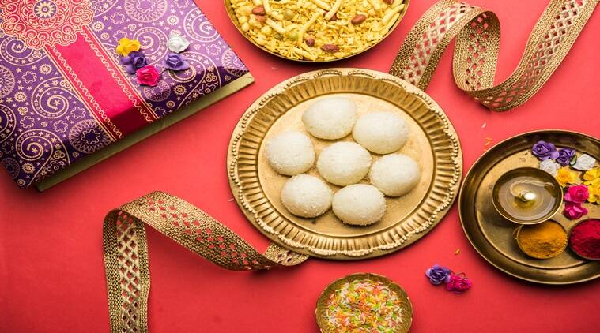

Fun Things to Do With the Kids on Bhai Dooj
- Organize a game especially for the siblings. Musical chairs, antakshari, dumb charades and board games always work. If your brothers are coming along, the kids can have a blast with their Mama and his family too.
- Whip up some Bhai Dooj special desserts. Yes, you are likely to have a lot of sweets left over from Diwali, but as they say, there’s nothing like too much mithaai! Better still; ask them to help with laying out sweets for the Bhai Dooj thali.
- Plan a story-telling session with a dash of mythology. Exchange stories about the traditions of Diwali and Bhai Dooj and just why it is important to stay connected to our roots. You could also watch some festive-themed films, or better still, shoot some with your video-camera!
- If you have an only child, don’t let him/her feel left out on this festival for siblings. Take them out for a treat to their favourite haunt, or organize a get-together with their cousins.

Reunite with your loved ones and enjoy the true blue traditions of India that are old as the hills but beautiful forever!

